**Web Designing Assignment**

**Term-1**

**Module (HTML) -01**

1. **Are the HTML tags and elements the same thing?**

**Ans.** HTML Tags and Elements are diffrent.

**HTML Tags:** HTML Tags Are Starting and Ending Parts of an HTML Element. Tags are genrally in pairs. All Tags starts with **"<"** and Ends with **">"** this Symbol.for Example:

Opening tag: <TagName> ( <p>,<b>,<H1>).

Closing tag: </TagName> ( </p>,</b>,</H1>).

**Elements:** Html Elements Are Components of web pages Html Elements Includes one starting,one ending tags and content. For Example:

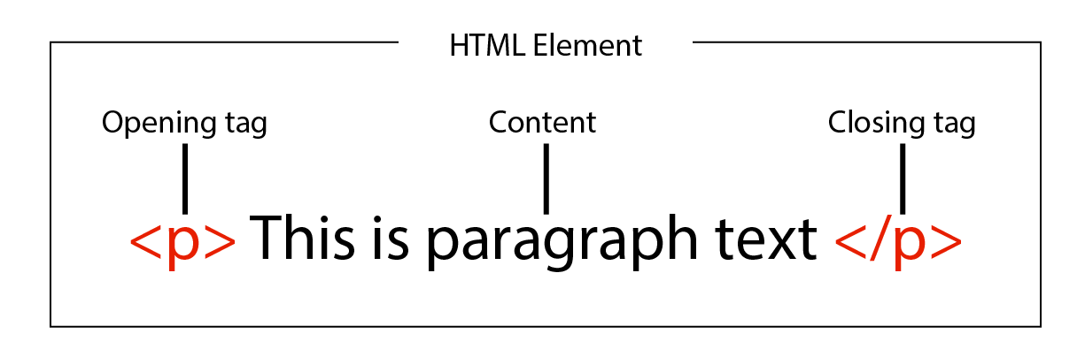

**2.What are tags and attributes in HTML?**

**HTML Tags:** HTML tags are markers enclosed in brackets **"< >"** that define the structure and content of elements on a web page. They mostly come in pairs, consisting of an opening tag and a closing tag, and they surround the content in an HTML Element.

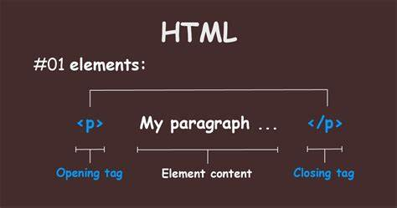

**HTML Attributes:** HTML attributes are additional properties or settings provided within the opening tag of an HTML element. They offer extra information or behavior for the element and are written as attribute_name="value".

HTML attributes are additional information provided within the opening tag of an HTML element.

They provide extra details or properties to the element.

Attributes are always written as attribute_name="value", enclosed within the opening tag.

Example of an HTML tag with an attribute:

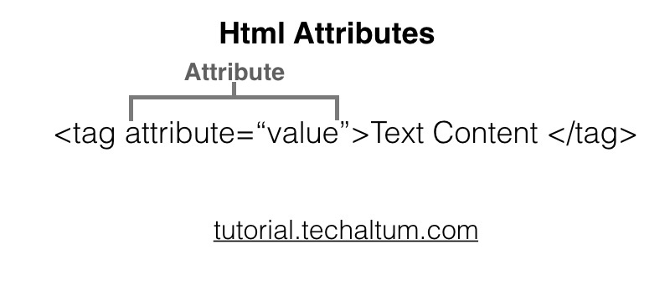

**3. What are void elements in HTML?**

**Void Elements in HTML:** In HTML, a "void element,"or "empty element," is a special type of HTML element that doesn't require a closing tag. Instead, these elements are self-contained within their opening tag. Void elements are mainly used to insert specific types of content or functionality into a web page. Here are some common examples of void elements:

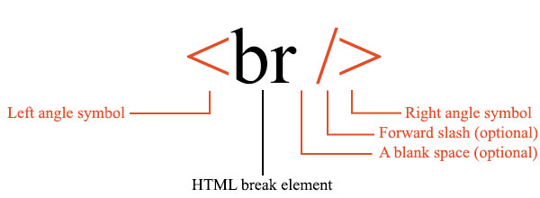

**4. What are HTML Entities?**

**HTML Entities:**

HTML entities or escape codes, are a way to represent special characters and symbols. They are used to display reserved characters, special symbols, and characters with special meanings in HTML.

HTML entities are constructed by placing an ampersand (&) at the beginning, followed by a unique code or name for the character, and closed with a semicolon (;). These entities help ensure that the intended character or symbol is correctly displayed on a web page.

Here are some commonly used HTML entities:

1. &lt; - Less Than Sign (<):
2. &gt; - Greater Than Sign (>):
3. &amp; - Ampersand (&):
4. &quot; - Double Quotation Mark ("):
5. &apos; or &#39; - Single Quotation Mark ('):
6. &nbsp; - Non-Breaking Space:

Inserts a space character that prevents line breaks or word wrapping.

**5. What are different types of lists in HTML?**

**Three types of lists in HTML are:**

1. **Ordered Lists (<ol>):**  
   Ordered lists are used to create lists with a specific order or sequence, typically displayed as numbered items.Each item in an ordered list is enclosed in <li> (list item) tags.The numbering (or other markers) is automatically generated by the browser.

Example of an ordered list:

**<ol>**

**<li>First item</li>**

**<li>Second item</li>**

**<li>Third item</li>**

**</ol>**

**Sub-Types of OrderList**

1. Numaric(1,2,3,4..)
2. Alphabatical Upper case (A,B,C...)
3. Alpabatical lower case(a,b,c..)
4. Roman upper case(i,ii,iii,iv...)
5. Roman lower case(I,II,III,IV...)
6. **Unorder List(<ul>):**  
   Unordered lists are used to create lists without a specific order or sequence, typically displayed as bulleted items.Each item in an unordered list is enclosed in <li> (list item) tags.Bullets or other markers are automatically generated by the browser.

Example of an unordered list:

**<ul>**

**<li>Apples</li>**

**<li>Oranges</li>**

**<li>Bananas</li>**

**</ul>**

**Sub-Types of Unorder list:**

1. **Disc**
2. **Circle**
3. **Square**

**3.Define List(dl):**

A description list is a list of terms, with a description of each term.

Then <dl> tag defines the description list, the <dt> tag defines the term (name), and the [<dd>](https://www.w3schools.com/tags/tag_dd.asp) tag describes each term:

Example:

<dl>  
  <dt>Coffee</dt>  
  <dd>- black hot drink</dd>  
  <dt>Milk</dt>  
  <dd>- white cold drink</dd>  
</dl>

* <dl> element to define a description list
* <dt> element to define the description term
* <dd> element to describe the term in a description list.

**6.What are the various formatting tags in HTML?**

**Formatting tags:**

In HTML some Tags are used in formatting text like

**Bold***, Italic* or undrlined etc.

**Examples:**

<b></b> = text in this tag turns **bold**.

<i></i> = text in this tag turns*Italic*.

<u></u>= text in this tag turns Underlined.

**7.How is Cell Padding different from Cell Spacing?**

**Cell padding:** it is used to take space padding in side the cell of a table. It defines the whitespace between the cell content and its border.

**<table cellpadding=”value” >**

**………………**

**</table>**

**Value = define how much padding you want.**

**Cell spacing:** it defines the whitespace between to cells or borders of cells. Used to take space between adjacent cells.

**<table cellspacing=”value”>**

**……………….**

**</table>**

**Value = define how much padding you want.**

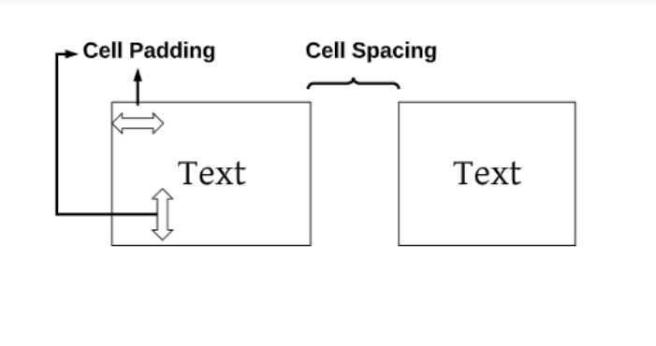

**8.How can we club two or more rows or columns into a single row or column in an HTML table?**

**Ans.** To club two or more rows or columns into a single row or column we can use HTML attributes “colspan” or “rowspan”.

To club rows use “rowspan”.

**Syntax:**

**<table>**

**<tr><td rowspan= ”value” >……. </td></tr>**

**</table>**

**Value = define how much padding you want.**

To club columns use “colspan”.

**Syntax:**

**<table>**

**<tr><td rowspan= ”value” >……. </td></tr>**

**</table>**

**Value = define how much padding you want.**

**9.** **What is the difference between a block-level element and an inline element?**

**Ans.** Both Block and inline elements have different default values.

|  |  |
| --- | --- |
| BLOCK | INLINE |
| Always starts from new line | Can be added between line |
| Take full space inline | Takes space as its need |

**Example:**

**Block elements:** div, p, nav, li etc…

**Inline element:** a, I, img, strong etc…

**10.** **How to create a Hyperlink in HTML?**

**Ans.** Html links are called hyperlinks to create these links we have to use an html element that is Anchor. Anchor tag denoted by “<a>”. link is created by putting the url or contend in “href” attribute.

**Syntax:**

**<a href="https://www.example.com">Visit Example.com</a>**

**For another html file.**

**<a href="example.html ">Visit Example.com</a>**

**11.** **What is the use of an “iframe” tag?**

**Ans. “**Iframe” tag is used to emmeble other web pages or website in your html page. You can emmeble a youtube, a googlemap or facebaook page etc.

**Syntax:**

<iframe src=" (URL of webpage) " title="title you want "></iframe>

**12.** **What is the use of a span tag? Explain with example?**

**Ans.** Span element is used for grouping inline elements. It can be used to separate a line or a single word of a paragraph to give it different style or something. It is just like div tag but the main difference between div and span is that div is a block element and span is an inline element.

**Here is an example of how to use the <span> tag:**

<p>My mother has <span style="color:blue">blue</span> eyes.</p>

In this example, the <span> tag is used to change the color of the text “blue” to blue. The text within the <span> tag is styled using CSS (Cascading Style Sheets).

**13.How to insert a picture into a background image of a web page?**

**Ans.** For inserting an image to background of a web page

We have to use “stayle” attribute css“background-image” property.

**Syntax:**

**<p style="background-image: url('example.jpg');">.**

**14.** **How are active links different from normal links?**

**Ans. Normal links:** Normal links are links that are not visited by the user or not yet clicked by user. These links appears underlined in blue color by default. Ones a user have clicked on a normal link it converts to an active link.

**Active links:** Active links are links that currently in use by the user. It is an temporary state that ends when user stop using that link.

**15. What are the different tags to separate sections of text?**

**Ans.** There are many tags in html that are used to saprate sections of text.

**Examples:**

* Section tag <section>: it makes a saction in web page to saprate its content from other.

**<saction>**

**<h1>Section 1</h1>**

**<p>Content of section 1</p>**

**</saction>**

* Paragraph tag <p>:it makes a paragraph of text. It is mostly used tag for making sactions of text in web pages.

**<p>Content of section 1</p>**

* Line break tag <br>: it makes a break in line or creates a gap(whitespace) in a web page. Main purpose of this is to break in line and start from other line.

**<p>Content of <br>section 1</p>**

Content in after <br> will be written

In next line.

These are some tags to make sections in a web page. there are many more tags to do this like <div>,<h1>,<hr> and article etc.

**16.** **What is SVG?**

**Ans.** SVG(Scalable Vector Graphics): SVG Stands Scalable vector graphic is an XML-based markup language used to define vector based graphic for web.

**17.** **What is difference between HTML and XHTML?**

**Ans.**HTML stands for Hypertext Markup Language and XHTML stands for Extensible Hypertext Markup Language. XHTML is an extension of HTML, which is stricter than HTML. Both languages are used to create web . HTML is SGML based. XHTML is an XML-based language. [The main difference between them is the syntax and structure; HTML is more lenient in its syntax, while XHTML has a more strict syntax and follows XML rules](https://www.geeksforgeeks.org/difference-between-xhtml-and-html5/). XHTML was developed to make HTML more flexible.

**18. What are logical and physical tags in HTML?**

**Ans.** Both Logical and Physical tags are used in Formatting text but they have different purposes.

**Logical tags:** logical tags formats text according to logical style. They describe the behaviour or nature of the content for the enclosed text.

Examples of logical tags:

<address>: Defines an address element.

<cite>: Defines citation.

<code>: Defines computer code text.

<blockquote>: Defines a long quotation.

**Physical tag:** Physical Tags are used in HTML to provide actual physical formatting to the text. [They define the way a text should be displayed in the browser, controlling their physical characteristics](https://www.geeksforgeeks.org/physical-and-logical-tags-in-html/).

<b>: Defines bold text.

<big>: Defines big text.

<i>: Defines italic text.

<small>: Defines small text.

**19. What is the ‘class’ attribute in HTML?**

**Ans.** Class attribute in html can be used in any element to specify it in a group or class. Class is used by Css and Javasciript to assign certain style or purpose to specified class or group of element.

**20.** **What is the difference between the ‘id’ attribute and the ‘class’ attribute of HTML elements?**

**Ans.** Class and id are basically same and also used for same purposes. The main difference between them is that a class can be assign to multiple elements on the same web page. While an id can be given to only one element.